**PayPal**

**Added 11.07.2017.**

Steps.

**Step 1:**

Go to the PayPal developers console

<https://developer.paypal.com/>

and click “Log into dashboard”.

**Step 2:**

Log in your developer profile here.

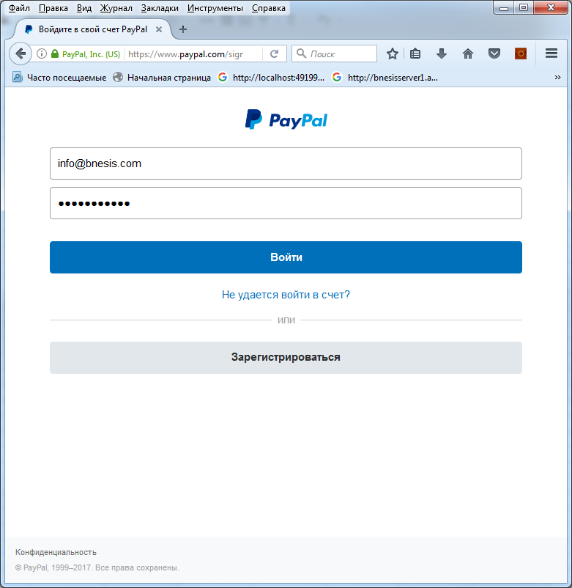

**Step 3:**

<https://developer.paypal.com/developer/accounts/>

Go to Accounts -> Sandbox Accounts and create sandbox account by clicking Create Account.

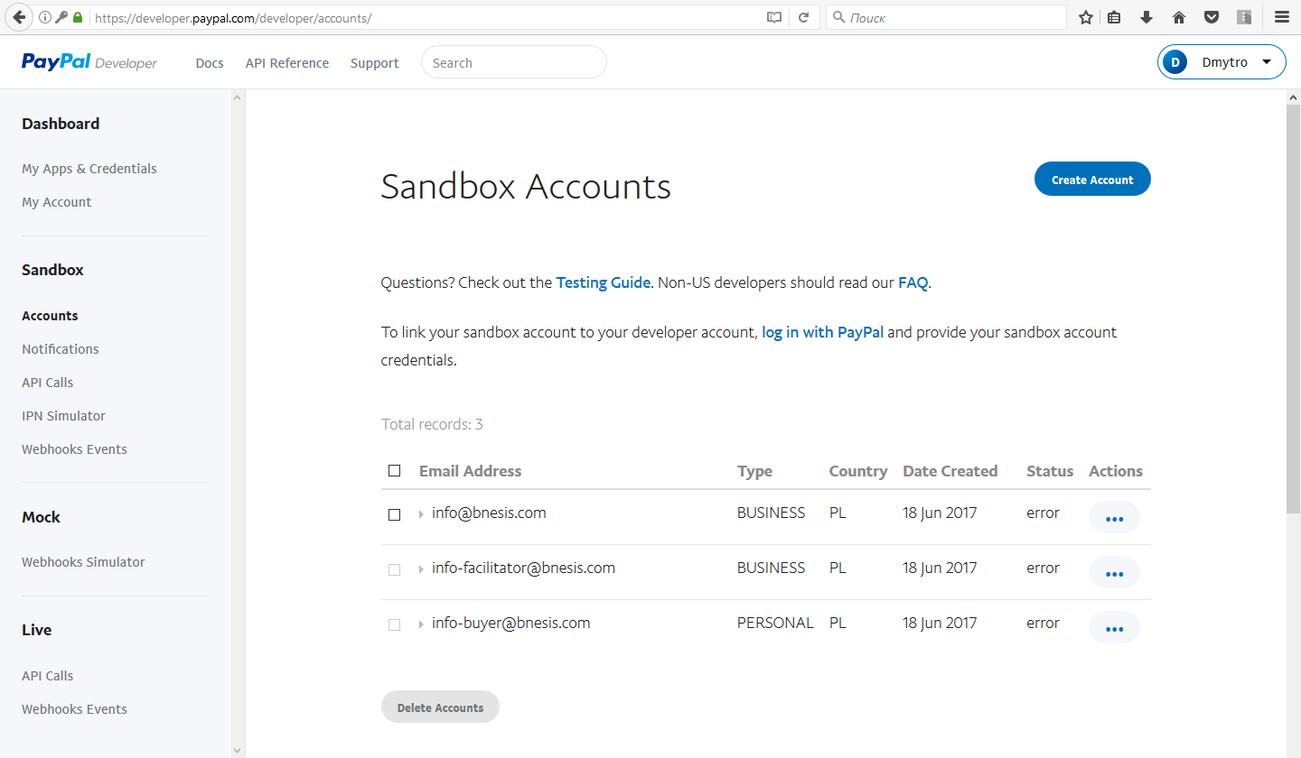

**Step 4:**

[https://developer.paypal.com/developer/applications](https://developer.paypal.com/developer/applications?country.x=RU&locale.x=ru_RU)

At My App & Credintials scroll down to REST API apps and click Create app.

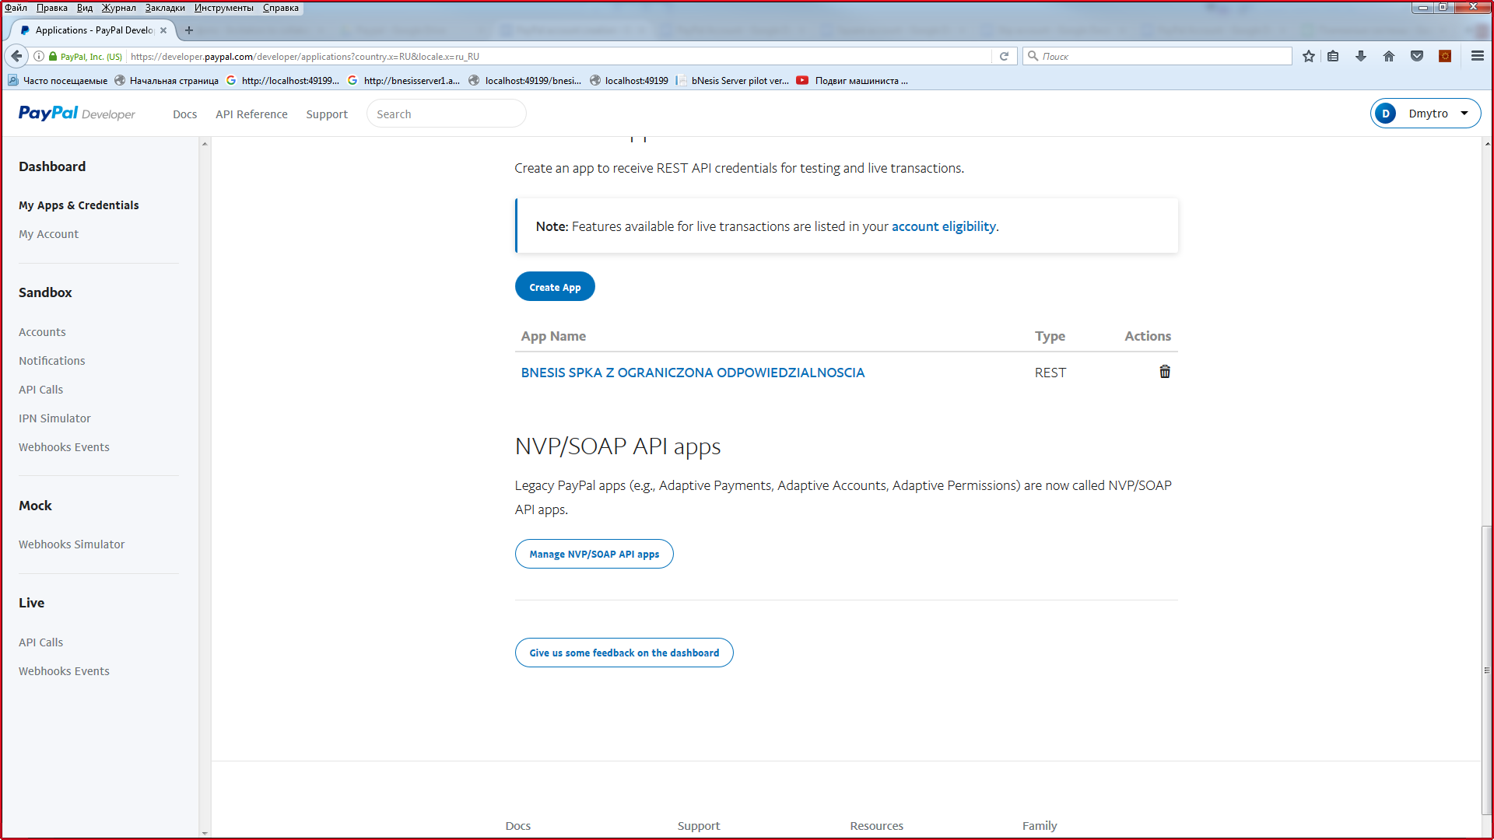

**Step 5:**

<https://developer.paypal.com/developer/applications/create>

Under At My App & Credintials -> REST API -> Create App Fill out Name of your application, select sandbox developer account and click Create App.

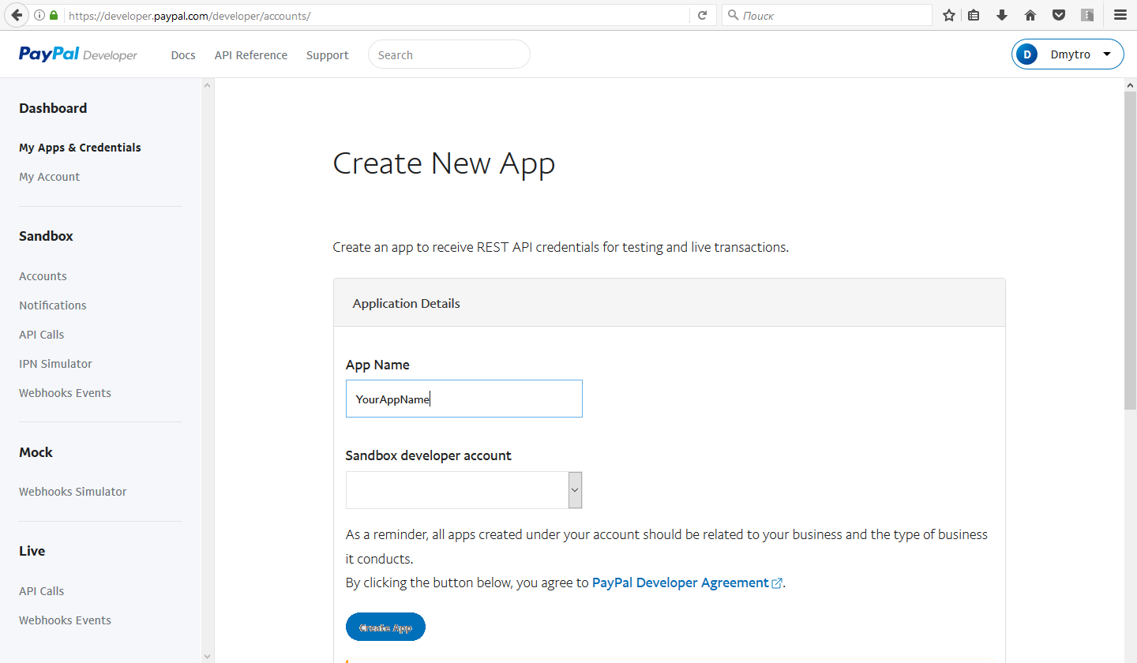

**Step 6:**

If You could not create Application with button Create App at the **Step 5** (i.e button Create App is disabled), but business Sanbox Account is already created, please contact with Paypal. You can use an example of request to Paypal:

[Example request to PayPal](https://drive.google.com/drive/folders/0Byr8bCqrFW9UWlpSdHQ4ZGtfU0E)

**Step 7:**

<https://developer.paypal.com/developer/applications/edit/QVJNYWgtMWdUSWR5N1ZvQVAycE8xUHlDV0xZdDZUSHp4Tjg5MUM2cy14V1RVeDZtemViSzhQeXM3ZDVyRFVoYVVmdm5ZTmdNRTBIZnlQZDk=>

Under At My App & Credintials -> REST API click on the name of your application and click to Show link to get Client ID and Client Secret for sandbox (if you need testing).

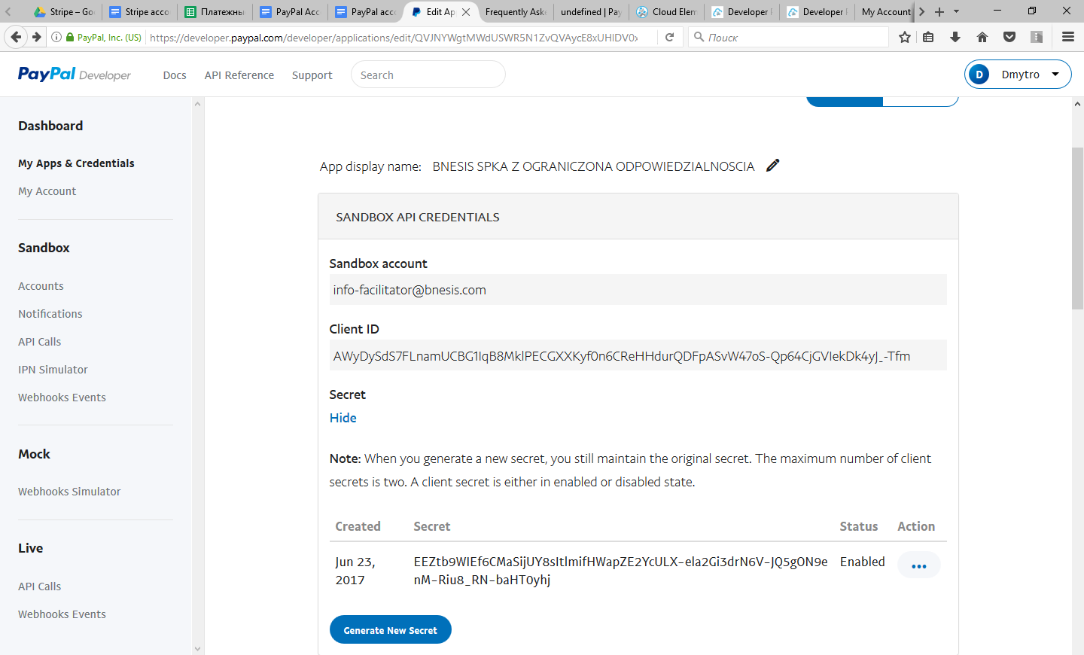

**Step 8:**

<https://developer.paypal.com/developer/applications/edit/QVJNYWgtMWdUSWR5N1ZvQVAycE8xUHlDV0xZdDZUSHp4Tjg5MUM2cy14V1RVeDZtemViSzhQeXM3ZDVyRFVoYVVmdm5ZTmdNRTBIZnlQZDk=>

Under At My App & Credintials -> REST API -> Your Application click on Live tab and and click to Show link to get Client ID and Client Secret for live transactions.

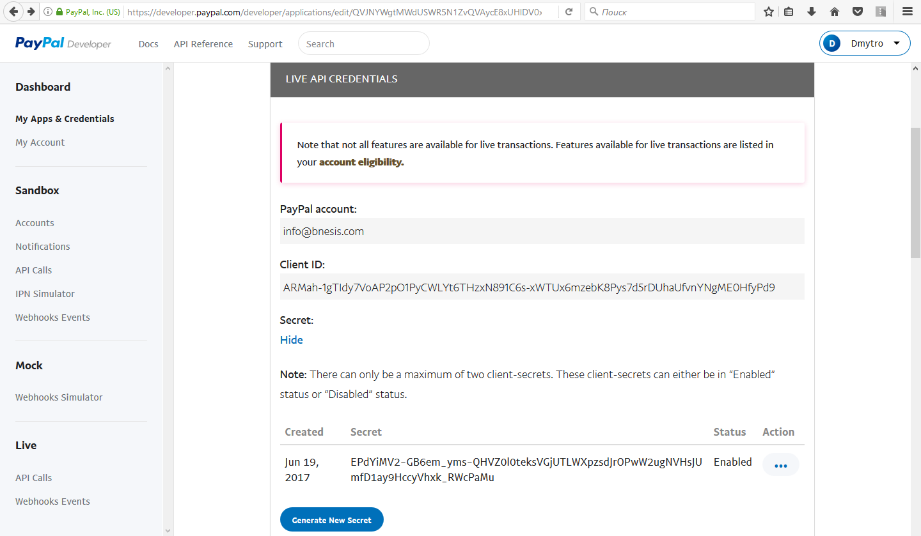

**Step 9:**

<https://developer.paypal.com/developer/applications/edit/QVJNYWgtMWdUSWR5N1ZvQVAycE8xUHlDV0xZdDZUSHp4Tjg5MUM2cy14V1RVeDZtemViSzhQeXM3ZDVyRFVoYVVmdm5ZTmdNRTBIZnlQZDk=>

Under At My App & Credintials -> REST API -> Your Application scroll down to SANDBOX APP SETTINGS and set Return URL.

